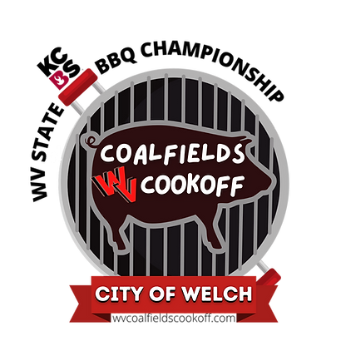

FOR IMMEDIATE RELEASE
June 13, 2023

Media contact: Andrea Ball, Festival Organizer
Mobile: 301.335.2715

City of Welch Announces Winners of the 2023 WV Coalfields Cookoff

Welch, W.Va.: Some of the best barbecue competition teams in the nation participated in the annual WV Coalfields Cookoff, the West Virginia State BBQ & ATV Festival, in Welch, WV. Held June 9-10, 2023, the Kansas City Barbeque Society-sanctioned event judged Master Series and Backyard Series teams in overall scores as well as chicken, ribs, pork, and brisket categories. The 2023 event was a recipient of the Smokin’ with Smithfield grant that provided an additional $3000 in prize money and welcomed over 1,500 visitors to downtown Welch over the two days festival.

“We were so pleased to have six of the top 10 KCBS Master Series teams as well as several of the top Backyard Series teams in the country cook for us this year,” said Welch Mayor Harold McBride. “We want to thank all of the teams, judges, vendors, sponsors and attendees for coming to the event. We are committed to providing quality entertainment options for our citizens and the added economic impacts of this event on McDowell County are immeasurably beneficial for CoalTown USA and the surrounding area.”

High on the Hog, a competitive barbecue team consisting of husband and wife, Shawn and Rebecca Surber from Ohio, was named Grand Champion at this year’s WV Coalfields Cookoff. The event was held June 9-10, 2023, in Welch, WV. The Surbers took home a prize of $3,500 for their win. High on the Hog also took home first place in the chicken and brisket categories, third in the ribs category and ninth in the pork category.

Off the Rack BBQ, of Virginia, was named Reserve Champion, and Swine ’N Roses BBQ of North Carolina placed first overall in the Backyard Series. Shawnbo’s BBQ of West Virginia won the People’s Choice award.

A complete list of competition results can be found on the Kansas City Barbeque Society website, https://mms.kcbs.us/members/evr/view_scores.php?org_id=KCBA&evid=45027935

The event was also proclaimed the WV State BBQ Championships by Governor Jim Justice and was sanctioned by the Kansas City BBQ Society (KCBS), for pro and backyard BBQ cook teams. The event also boasted live bands, vendors; a beer garden with proceeds benefiting the Welch Volunteer Fire Department and a BBQ tasting. Dates of the 2024 WV Coalfields Cookoff will be June 7-8, 2024.

###

